**My Jesus,**

**I believe that you are present in this Holy Sacrament of the altar.**

**I love you above all things and I passionately desire to receive you into my soul.**

**Since I cannot now receive you sacramentally,**

**come spiritually into my soul**

**so that I may unite myself wholly to you now and forever. Amen.**

*based on a prayer of St Alphonsus Liguori*

At the Saviour’s command

and formed by divine teaching, we dare to say:

**Our Father, who art in heaven,**

**hallowed be thy name;**

**thy kingdom come,**

**thy will be done**

**on earth as it is in heaven.**

**Give us this day our daily bread,**

**and forgive us our trespasses,**

**as we forgive those who trespass against us;**

**and lead us not into temptation,**

**but deliver us from evil.**

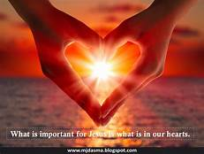

**Concluding Prayer**

Renewed by this bread from the heavenly table, we beseech you, Lord, that, being the food of charity, it may confirm our hearts and stir us to serve you in our neighbour. Through Christ our Lord. Amen.

**Spiritual Communion**

**22nd Sunday in Ordinary Time**

**Sunday 29 August 2021**

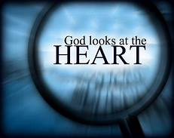

**Opening Prayer**

God of might, giver of every good gift, put into our hearts the love of your name, so that, by deepening our sense of reverence, you may nurture in us what is good and, by your watchful care, keep safe what you have nurtured. Through our Lord Jesus Christ, your Son, who lives and reigns with you in the unity of the Holy Spirit, God, for ever and ever. Amen.

**Deuteronomy 4:1-2,6-8**

Moses said to the people: ‘Now, Israel, take notice of the laws and customs that I teach you today, and observe them, that you may have life and may enter and take possession of the land that the Lord the God of your fathers is giving you. You must add nothing to what I command you, and take nothing from it, but keep the commandments of the Lord your God just as I lay them down for you. Keep them, observe them, and they will demonstrate to the peoples your wisdom and understanding. When they come to know of all these laws they will exclaim, “No other people is as wise and prudent as this great nation.” And indeed, what great nation is there that has its gods so near as the Lord our God is to us whenever we call to him? And what great nation is there that has laws and customs to match this whole Law that I put before you today?’

**The Word of the Lord**

**James 1:17-18,21-22,27**

It is all that is good, everything that is perfect, which is given us from above; it comes down from the Father of all light; with him there is no such thing as alteration, no shadow of a change. By his own choice he made us his children by the message of the truth so that we should be a sort of first-fruits of all that he had created.

Accept and submit to the word which has been planted in you and can save your souls. But you must do what the word tells you, and not just listen to it and deceive yourselves.

Pure, unspoilt religion, in the eyes of God our Father is this: coming to the help of orphans and widows when they need it, and keeping oneself uncontaminated by the world.

**The Word of the Lord**

**Gospel Acclamation**

**Alleluia, alleluia!**

**Your words are spirit, Lord, and they are life;**

**you have the message of eternal life.**

**Alleluia!**

**A reading from the holy Gospel according to Mark**

7:1-8,14-15,21-23

The Pharisees and some of the scribes who had come from Jerusalem gathered round Jesus, and they noticed that some of his disciples were eating with unclean hands, that is, without washing them. For the Pharisees, and the Jews in general, follow the tradition of the elders and never eat without washing their arms as far as the elbow; and on returning from the market place they never eat without first sprinkling themselves. There are also many other observances which have been handed down to them concerning the washing of cups and pots and bronze dishes. So these Pharisees and scribes asked him, ‘Why do your disciples not respect the tradition of the elders but eat their food with unclean hands?’ He answered, ‘It was of you hypocrites that Isaiah so rightly prophesied in this passage of scripture:

This people honours me only with lip-service,

while their hearts are far from me.

The worship they offer me is worthless,

the doctrines they teach are only human regulations.

You put aside the commandment of God to cling to human traditions.’ He called the people to him again and said, ‘Listen to me, all of you, and understand. Nothing that goes into a man from outside can make him unclean; it is the things that come out of a man that make him unclean. For it is from within, from men’s hearts, that evil intentions emerge: fornication, theft, murder, adultery, avarice, malice, deceit, indecency, envy, slander, pride, folly. All these evil things come from within and make a man unclean.’

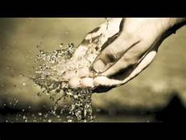**The Gospel of the Lord**