**olMy Jesus,**

**I believe that you are present in this Holy Sacrament of the altar.**

**I love you above all things and I passionately desire to receive you into my soul.**

**Since I cannot now receive you sacramentally,**

**come spiritually into my soul**

**so that I may unite myself wholly to you now and forever. Amen.**

*based on a prayer of St Alphonsus Liguori*

At the Saviour’s command

and formed by divine teaching, we dare to say:

**Our Father, who art in heaven,**

**hallowed be thy name;**

**thy kingdom come,**

**thy will be done**

**on earth as it is in heaven.**

**Give us this day our daily bread,**

**and forgive us our trespasses,**

**as we forgive those who trespass against us;**

**and lead us not into temptation,**

**but deliver us from evil.**



**Concluding Prayer**

O God, who bestow heavenly gifts upon your Church, safeguard, we pray, the grace you have given, that the gift of the Holy Spirit poured out upon her may retain all its force and that this spiritual food may gain her abundance of eternal redemption. Through Christ our Lord. Amen.

**Spiritual Communion - Pentecost**

**Sunday 5 June 2022**

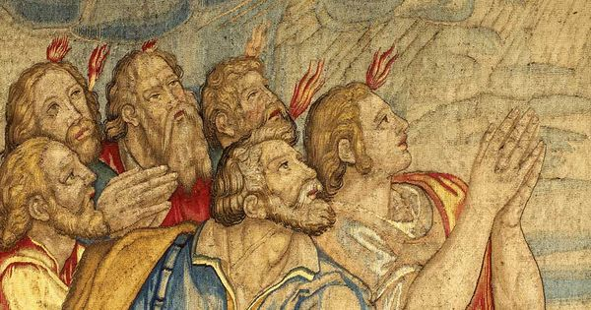

**Opening Prayer**

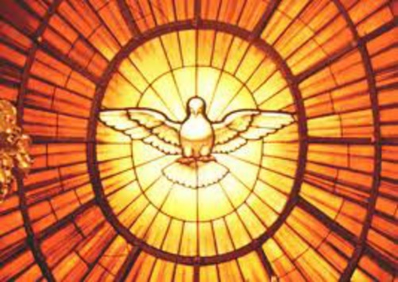O God, who by the mystery of today’s great feast sanctify your whole Church in every people and nation, pour out, we pray, the gifts of the Holy Spirit across the face of the earth and, with the divine grace that was at work when the Gospel was first proclaimed, fill now once more the hearts of believers. Through our Lord Jesus Christ, your Son, who lives and reigns with you in the unity of the Holy Spirit, God, for ever and ever. Amen.

**Acts 2:1-11**

When Pentecost day came round, they had all met in one room, when suddenly they heard what sounded like a powerful wind from heaven, the noise of which filled the entire house in which they were sitting; and something appeared to them that seemed like tongues of fire; these separated and came to rest on the head of each of them. They were all filled with the Holy Spirit, and began to speak foreign languages as the Spirit gave them the gift of speech.

Now there were devout men living in Jerusalem from every nation under heaven, and at this sound they all assembled, each one bewildered to hear these men speaking his own language. They were amazed and astonished. ‘Surely’ they said ‘all these men speaking are Galileans? How does it happen that each of us hears them in his own native language? Parthians, Medes and Elamites; people from Mesopotamia, Judaea and Cappadocia, Pontus and Asia, Phrygia and Pamphylia, Egypt and the parts of Libya round Cyrene; as well as visitors from Rome – Jews and proselytes alike – Cretans and Arabs; we hear them preaching in our own language about the marvels of God.’

**The Word of the Lord**

**Responsorial Psalm**

**Send forth your spirit, O Lord, and renew the face of the earth.**

Bless the Lord, my soul!

Lord God, how great you are,

How many are your works, O Lord!

The earth is full of your riches.

You take back your spirit, they die,

returning to the dust from which they came.

You send forth your spirit, they are created;

and you renew the face of the earth.

May the glory of the Lord last for ever!

May the Lord rejoice in his works!

May my thoughts be pleasing to him.

I find my joy in the Lord.

**1 Corinthians 12:3-7,12-13**

No one can say, ‘Jesus is Lord’ unless he is under the influence of the Holy Spirit.

There is a variety of gifts but always the same Spirit; there are all sorts of service to be done, but always to the same Lord; working in all sorts of different ways in different people, it is the same God who is working in all of them. The particular way in which the Spirit is given to each person is for a good purpose.

Just as a human body, though it is made up of many parts, is a single unit because all these parts, though many, make one body, so it is with Christ. In the one Spirit we were all baptised, Jews as well as Greeks, slaves as well as citizens, and one Spirit was given to us all to drink.

**The Word of the Lord**

**Gospel Acclamation**

**Alleluia, alleluia!**

**Come, Holy Spirit, fill the hearts of your faithful**

**and kindle in them the fire of your love.**

**Alleluia!**

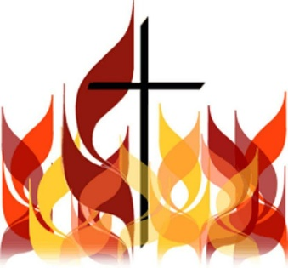**A reading from the holy Gospel according to John 14:15-16,23-26**

Jesus said to his disciples:

‘If you love me you will keep my commandments. I shall ask the Father, and he will give you another Advocate to be with you for ever.

‘If anyone loves me he will keep my word, and my Father will love him, and we shall come to him and make our home with him. Those who do not love me do not keep my words. And my word is not my own: it is the word of the one who sent me. I have said these things to you while still with you; but the Advocate, the Holy Spirit, whom the Father will send in my name, will teach you everything and remind you of all I have said to you.

**The Gospel of the Lord**