**My Jesus,**

**I believe that you are present in this Holy Sacrament of the altar.**

**I love you above all things and I passionately desire to receive you into my soul.**

**Since I cannot now receive you sacramentally,**

**come spiritually into my soul**

**so that I may unite myself wholly to you now and forever. Amen.**

*based on a prayer of St Alphonsus Liguori*

At the Saviour’s command

and formed by divine teaching, we dare to say:

**Our Father, who art in heaven,**

**hallowed be thy name;**

**thy kingdom come,**

**thy will be done**

**on earth as it is in heaven.**

**Give us this day our daily bread,**

**and forgive us our trespasses,**

**as we forgive those who trespass against us;**

**and lead us not into temptation,**

**but deliver us from evil.**

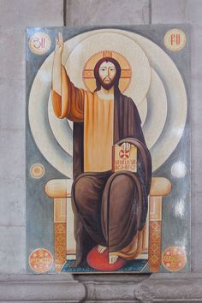

**Concluding Prayer**

Having received the food of immortality, we ask, O Lord, that, glorying in obedience to the commands of Christ, the King of the universe, we may live with him eternally in his heavenly kingdom. Who lives and reigns for ever and ever. Amen.

**Spiritual Communion – Solemnity of Christ the King**

**Sunday 20 November 2022**

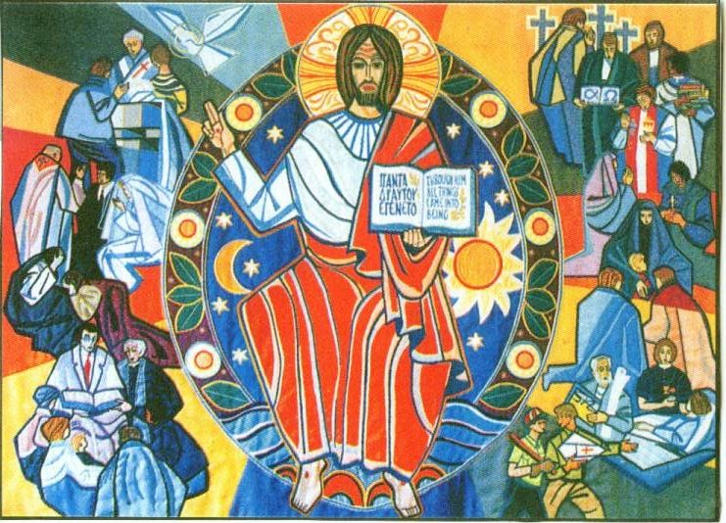

**Opening Prayer**

Almighty ever-living God, whose will is to restore all things in your beloved Son, the King of the universe, grant, we pray, that the whole creation, set free from slavery, may render your majesty service and ceaselessly proclaim your praise. Through our Lord Jesus Christ, your Son, who lives and reigns with you in the unity of the Holy Spirit,

God, for ever and ever. Amen.

**2 Samuel 5:1-3**

All the tribes of Israel then came to David at Hebron. ‘Look’ they said ‘we are your own flesh and blood. In days past when Saul was our king, it was you who led Israel in all their exploits; and the Lord said to you, “You are the man who shall be shepherd of my people Israel, you shall be the leader of Israel.”’ So all the elders of Israel came to the king at Hebron, and King David made a pact with them at Hebron in the presence of the Lord, and they anointed David king of Israel.

The Word of the Lord

**Responsorial Psalm**

**I rejoiced when I heard them say: ‘Let us go to God’s house.’**

I rejoiced when I heard them say:

‘Let us go to God’s house.’

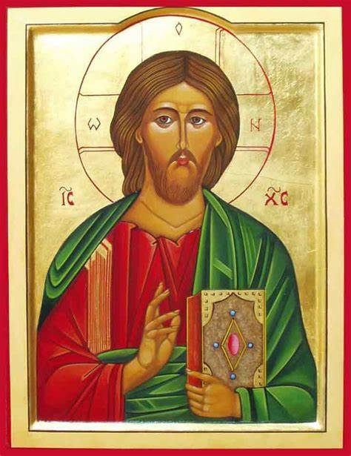And now our feet are standing

within your gates, O Jerusalem.

Jerusalem is built as a city

strongly compact.

It is there that the tribes go up,

the tribes of the Lord.

For Israel’s law it is,

there to praise the Lord’s name.

There were set the thrones of judgement

of the house of David.

**Colossians 1:12-20**

We give thanks to the Father who has made it possible for you to join the saints and with them to inherit the light.

Because that is what he has done: he has taken us out of the power of darkness and created a place for us in the kingdom of the Son that he loves, and in him, we gain our freedom, the forgiveness of our sins.

He is the image of the unseen God and the first-born of all creation, for in him were created all things in heaven and on earth: everything visible and everything invisible, Thrones, Dominations, Sovereignties, Powers – all things were created through him and for him. Before anything was created, he existed, and he holds all things in unity. Now the Church is his body, he is its head.

As he is the Beginning, he was first to be born from the dead, so that he should be first in every way; because God wanted all perfection

to be found in him and all things to be reconciled through him and for him, everything in heaven and everything on earth, when he made peace by his death on the cross.

**The Word of the Lord**

**Gospel Acclamation**

**Alleluia, alleluia!**

**Blessings on him who comes in the name of the Lord!**

**Blessings on the coming kingdom of our father David!**

**Alleluia!**

**A reading from the holy Gospel according to Luke 23:35-43**

The people stayed there before the cross watching Jesus. As for the leaders, they jeered at him. ‘He saved others,’ they said ‘let him save himself if he is the Christ of God, the Chosen One.’ The soldiers mocked him too, and when they approached to offer vinegar they said, ‘If you are the king of the Jews, save yourself.’ Above him there was an inscription: ‘This is the King of the Jews.’

One of the criminals hanging there abused him. ‘Are you not the Christ?’ he said. ‘Save yourself and us as well.’ But the other spoke up and rebuked him. ‘Have you no fear of God at all?’ he said. ‘You got the same sentence as he did, but in our case we deserved it: we are paying for what we did. But this man has done nothing wrong. Jesus,’ he said ‘remember me when you come into your kingdom.’ ‘Indeed, I promise you,’ he replied ‘today you will be with me in paradise.’

**The Gospel of the Lord**